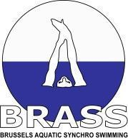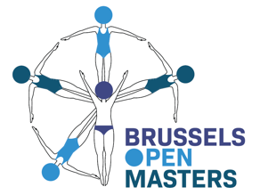

INVITATION - Brussels Open Masters (BOM)
Masters Artistic swimming championship

The Brussels aquatic synchro swimming club has the pleasure to invite you to the 15th Brussels Open Masters on April 10th-11th-12th, 2026.

Venue: | Neptunium Swimming Pool – Rue de Jerusalem 58, 1030 Bruxelles

Rules: | Age Categories  Age shall be determined as of December 31st of the year of competition. The competitors must be 20 years old in 2026. The average age of the competitors in a routine shall be determined by adding the ages of the registered swimmers (not including reserves), dividing by the number of swimmers (not including reserves) and dropping any resulting fraction or decimal. (For example, if the average age of a Team is 49.833, they would swim in the 35-49 age group).  There will be a category of 20 – 24 for solo/ duo, team and combo.  Anyway, the swimmers who are less than 25 years old can participate in a team of any categories; categories will be defined based on the average age of the team.  Men can participate. There will be a category “mixed duet” and “Men solo”. For all the other categories, men and women will compete together.  Categories  Solo: 20-24, 25-29, 30-39, 40-49, 50-59, 60- 69, 70-79, 80 and over  Duet: 20-24, 25-29, 30-39, 40-49, 50-59, 60 69, 70-79, 80 and over  Team: 20-24, 25-34, 35-49, 50-64, 65-79 and 80 and over  Combination 20-24, 25-39; 40-64 and 65 and over  Teams shall consist of a minimum of four (4) members and a maximum of eight (8) members. Combination shall consist of a minimum of four (4) members and a maximum of ten (10) members.  There isn’t any trio this year.  Each event is a separate medal event. So the composition of the duets and teams can be different between tech and free routine.

Entries: | No limitation in number of solos, duos, teams, combos per category. BUT to avoid the rush of last year we have decided to limit the registrations. So it will be : first arrived, first registered. We will stop the  subscription when about 250 routines will be reached. The pre-registered teams will have priority.  For an optimized organization, 1 judge per club is requested for clubs with less or equal to 10 competitors, 2 judges are required for clubs with more than 10 competitors. The fee is 50 euros if the club has no judges and 5 swimmers or less and 75 euros if the club has no judges and 6 swimmers or more. The judges can swim too.

Financial  conditions: | Pré-registration fee (to pay to confirm the preregistration – not refundable but deduced of the final invoice)  10 euros for each swimmer pre-registered  These fees must be paid before December 31st on our bank account:  Brussels Aquatic Synchro Swimming  IBAN : BE55 0003 2547 8244  BIC : GEBA BE BB  Registration fee (to pay with the final registration form – refundable with medical certificate only – Dead line : 10/3).  15 euros for a tech solo  15 euros for a free solo  25 euros for a tech duet  25 euros for a free duet  80 euros for a tech team  80 euros for a free team  100 euros for a combo  50 euros if the club has no judge and 5 swimmers or less  75 euros if the club has no judge and 6 swimmers or more

Entry: | Preliminary entry: December 31st 2025  Final entry and musics: March 1st 2026 (you will receive a new form for these)
Preliminary Schedule: | Friday, 10th  Saturday, 11th
  17.30-18.30 | Warm-up – meeting – welcome drink
  19.00-22.00 | Solo free (all age categories)
  22.00 | Medal ceremony
  7.30-8.30 | Warm-up
  8.30-9.00 | Judges and team leaders meeting
  9.00-10.30 | Team – technical routine
  10.30-11.00 | Warm-up
  11.00-14.00 | Solo – technical routine
  14.00-14.30 | Warm-up
  14.30-17.30 | Duo – technical routine
  17.30-18.30 | Warm-up
  18.30-21.30 | Team – free routine
  21.30 | Medal ceremony (maybe one ceremony before team too)
Sunday, 12th
8.00-9.00 | Warm-up
8.30-9.00 | Judges and team leaders meeting
9.00-11.00 | combo
11.00-12.00 | Warm-up
12.00-16.00 | Free duet
16.30 | Medal ceremony (maybe one ceremony for combe before duet)

 | The schedule may be adapted based on the number of competitors.

With kind regards,

Fanny Bouvry

Tel : +32 477 75 88 82
E-mail: brusselsopenmasters@gmail.com
www.ebrass.be
@club_brass on Instagram
@brusselsopenmasters on Instagram

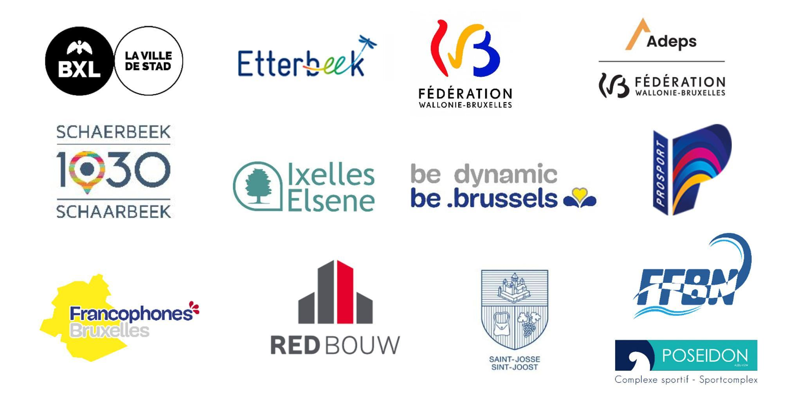

Required elements for masters technical routine and time limits

MAXIMUM TIME LIMITS

-Technical Routines Solo : 2 minutes
-Free Routines Solo: 2 minutes 15 seconds
-Technical Routines Duet and Mixed Duet: 2 minutes 20 seconds
-Free Routines Duet and Mixed Duet: 2 minutes 45 seconds
-Technical Routines Teams: 2 minutes 50 seconds
-Free Routines Teams: 3 minutes 30 seconds
-Free Combination: 3 minutes 30 seconds

Time limits for Technical Routines and Free Routines including ten seconds for the deck movement.

The walk-on time is max 30 sec. There shall be no minimum time limit.

FINA REQUIRED ELEMENTS FOR MASTERS TECHNICAL ROUTINES

GENERAL REQUIREMENTS

Supplementary elements may be added

1. Unless otherwise specified in the description of an element:
• All figures or components thereof shall be executed according to the
requirements described in this Appendix.
• All elements shall be executed high and controlled in uniform motion
with each section clearly defined.

2. In both tech and free routines, swimwear must conform to LEN and World Aquatics rules. Caps and/or goggles may be worn. So no black jersey and white cap required for technical routines.

3. For technical routines, all technical elements can be performed in the axis of your choice
and without any mandatory order (elements card)

SOLO REQUIRED ELEMENTS

Elements 1 to 5 should follow the order listed on the Elements Order Card. Element 6 may be

1. FISHTAIL – from a Front Layout Position, a Front Pike Position is
assumed; one leg is lifted to a Fishtail Position, the second leg is lifted to a
Vertical Position (ending is optional).

2. SPLIT POSITION – followed by a walkout front or walkout back.

3. SPINNING 180° – From a Bent Knee Position, a Spin 180° is executed as
the legs are joined to a Vertical Position at the ankles followed by
submergence.

4. TRAVELLING BALLET LEG – Beginning in a Back Layout. A right and a left ballet-legs are executed (elements)

5. BARRACUDA BENT KNEE – From the Back Pike Position with the legs
perpendicular and the toes just below the surface, a Thrust is executed as one
leg is drawn along the inside of the other extended leg to assume a Bent Knee
Vertical Position. A Vertical Descent is executed in a Bent Knee Vertical
Position at the same tempo as the Thrust

6. TWO (2) FORMS OF PROPULSION – Must include Egg Beater travelling
sideways and/or forward (arms optional)

DUET REQUIRED ELEMENTS

Elements 1 – 5 should follow the order listed on the Elements Order Card. Elements 6 – 7 may be executed at any time during the routine

Routines for Duet 1 to 6 as above for Solo
7. JOINED ACTION – Where the swimmers are connected (touching) in some
manner to perform on of the following:
• A connected figure or a connected float or connected stroking
• Action must be performed simultaneously. Minor action is permitted.
• Stacks, lifts, platforms, throws are not permitted.

With the exception of the DECK WORK and ENTRY and as noted in the JOINED
ACTION, all elements, required and supplementary, MUST be performed
simultaneously and facing the same direction by both swimmers, Variation in
propulsion and direction facing are permitted during pattern changes.

TEAM REQUIRED ELEMENTS

Elements 1 – 5 should follow the order listed on the Elements Order Card. Elements 6 – 9 may be executed at any time during the routine.

Routines for Team 1 to 7 as above for Duet

8. CADENCE ACTION – Identical movements performed sequentially, one by
one, by all team members. When more than one cadence action is performed,
they must be consecutive and nor separated by other optional or required
elements. A second cadence action may begin before the first cadence action
is completed by all team members but each team member must do the action
of each cadence.

9. PATTERNS – must show a circle and straight line. Elements may be performed
when in the circle or the straight-line patterns.

With the exception of the DECK WORK, ENTRY, CADENCE and as noted in the
JOINED ACTION, all elements, required and supplementary, MUST be performed
simultaneously and facing the same direction by all swimmers. Swimmers need not
face the same direction in the circle pattern. Variation in propulsion and direction
facing are permitted during pattern changes. Mirror actions are not permitted except
in the description of the elements.

